

**Software User’s Guide:**

**VPRINT for Windows**

**Version 1.0.5357**

**VPrint**

**Prepared for:**

**Premier Tax Free (Ltd.) UK**

**Prepared by:**

**Mr. Rosen Rusev**

**Somerset House,**

**47-49 London Rd,**

**Redhill, Surrey**

**RH1 1LU**

**Tel: +44 1737 644922**

**Email:** [**rosen.rusev@uk.premiertaxfree.com**](mailto:rosen.rusev@uk.premiertaxfree.com)

**September 2014**

**ACKNOWLEDGMENTS**

**This VPRINT for Windows upgrade is the result of work performed by Rosen Rusev.**

**TABLE OF CONTENTS**

INTRODUCTION 4

What voucher is? 4

What VPrint is? 4

GETTING STARTED 4

OPERATING SYSTEM REQUIREMENTS 4

If you want to run Windows 7 on your PC, here's what it takes: 4

Additional requirements to use certain features: 4

PCs with multi-core processors 4

PCs with multiple processors (CPUs) 4

INSTALLATION 5

STARTING VPRINT 5

LOG IN THE APPLICATION 5

WHERE ELSE TO GET HELP 5

USING VPRINT 6

APPEARANCE 6

STEP 1: SELECTING HEADOFFICE 6

DROP HEADOFFICE DROPDOWN AND SELECT HEADOFFICE 6

STEP2: SELECTING RETAILER 7

DROP RETAILER DROPDONW AND SELECT RETAILER 7

STEP3: SELECTING SINGLE SELL OR DOUBLE SELL 7

STEP 3: PRINTING 8

PRINT UNALLOCATED VOUCHERS 8

SELECT ALLOCATIONS TO REPRINT 8

REPRINT ALLOCATIONS 9

CONFIRM REPRINT 9

REPRINT FROM LOCAL CACHE 10

BLOCKING VOUCHERS 10

Thank you! 11

# INTRODUCTION

## What voucher is?

Voucher is a copy of a payment document taken from original paper voucher. Voucher may contain many pages or documents attached. It may contain other files as text files, office files, multimedia files, and other image files and so on. It may be either raw, encrypted, signed or credit card covered.

## What VPrint is?

VPrint is a high performance desktop client for printing vouchers.

# GETTING STARTED

## OPERATING SYSTEM REQUIREMENTS

VPrint is Desktop Windows application. In order to run proper it requires following:

### If you want to run Windows 7 on your PC, here's what it takes:

* 1 gigahertz (GHz) or faster 32-bit (x86) or [**64-bit (x64)**](http://windows.microsoft.com/en-gb/windows7/products/features/64-bit-support) processor
* 1 gigabyte (GB) RAM (32-bit) or 2 GB RAM (64-bit)
* 16 GB available hard disk space (32-bit) or 20 GB (64-bit)
* DirectX 9 graphics device with WDDM 1.0 or higher driver

### Additional requirements to use certain features:

* Internet access (fees may apply)
* Depending on resolution, video playback may require additional memory and advanced graphics hardware
* DVD/CD authoring requires a compatible optical drive
* Music and sound require audio output

Product functionality and graphics may vary based on your system configuration. Some features may require an advanced or additional hardware.

PCs with multi-core processors  
Windows 7 was designed to work with today's multi-core processors. All 32-bit versions of Windows 7 can support up to 32 processor cores, while 64‑bit versions can support up to 256 processor cores.

PCs with multiple processors (CPUs)  
Commercial servers, workstations, and other high-end PCs may have more than one physical processor. Windows 7 Professional, Enterprise, and Ultimate allow for two physical processors, providing the best performance on these computers. Windows 7 Starter, Home Basic, and Home Premium will recognize only one physical processor.

## INSTALLATION

To install application locally run installer. You need to run administrative account.

## STARTING VPRINT

Find application icon on your desktop and double click on it.



## LOG IN THE APPLICATION

VPrint operates sensitive data. Authenticating user is essential.   
In log in windows enter your TRS credit tails (user name, password and country). Click “Enter”.

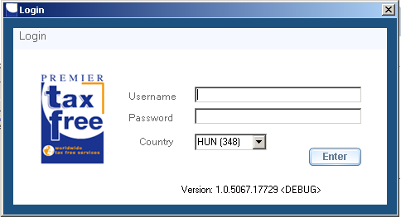

## WHERE ELSE TO GET HELP

To get more help click “Help” menu option in main menu or go to link <https://192.168.53.143/FintraxPTFImages/Help>.

# USING VPRINT

## APPEARANCE

VPrint is a windows forms application. It has got three tabs. To run it, click on and open “Print” tab. See image.

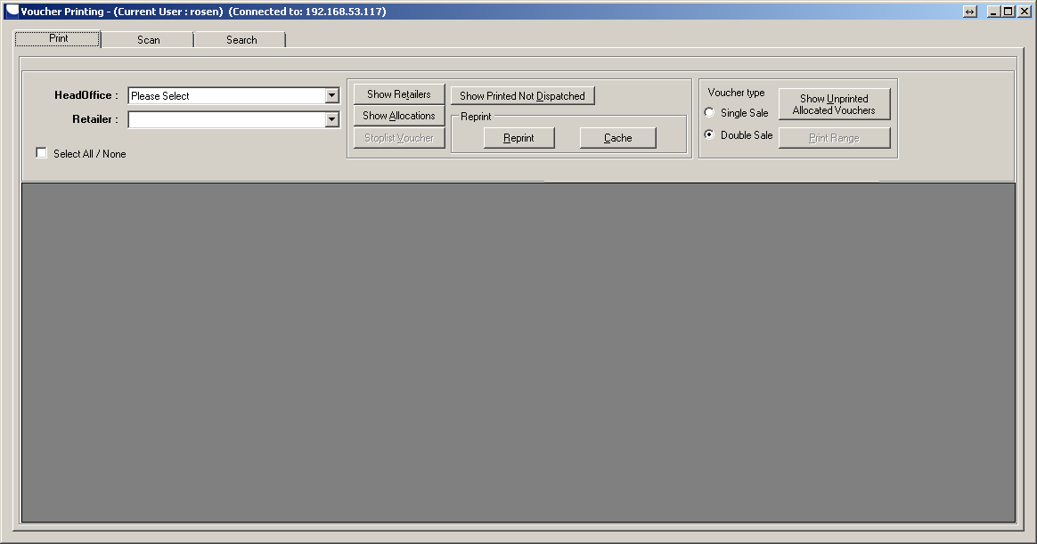

# STEP 1: SELECTING HEADOFFICE

## DROP HEADOFFICE DROPDOWN AND SELECT HEADOFFICE

Click on the button next to the dropdown to load retailers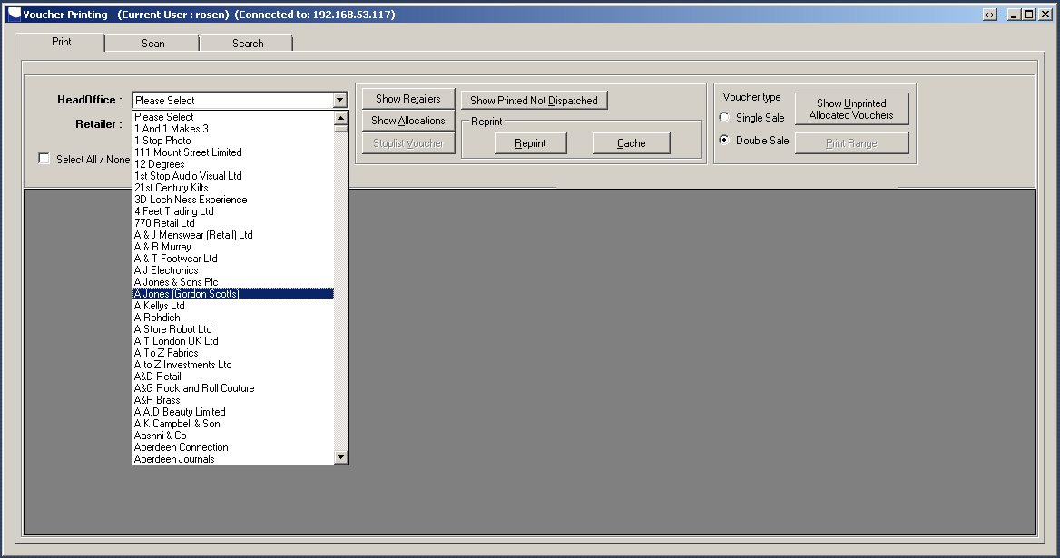

# STEP2: SELECTING RETAILER

## DROP RETAILER DROPDONW AND SELECT RETAILER

Click on the button next to the dropdown to load allocations

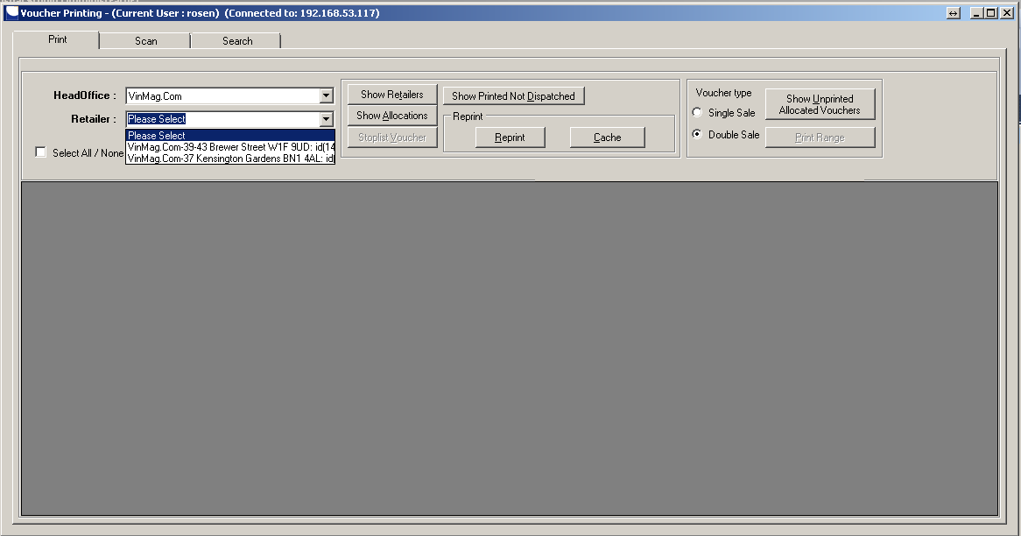

# STEP3: SELECTING SINGLE SELL OR DOUBLE SELL

To select “Single sell” or “Double sell” use radio button group shown

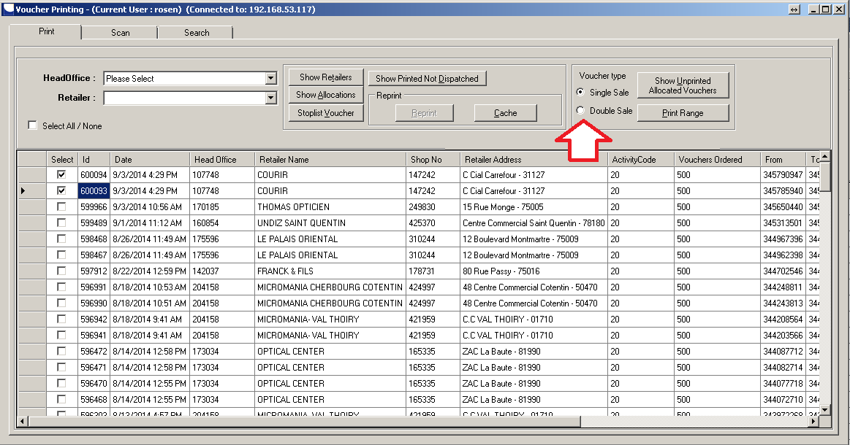

# STEP 3: PRINTING

## PRINT UNPRINTED, ALLOCATED VOUCHERS

To print unprinted, allocated vouchers click “Show Unprinted vouchers” button

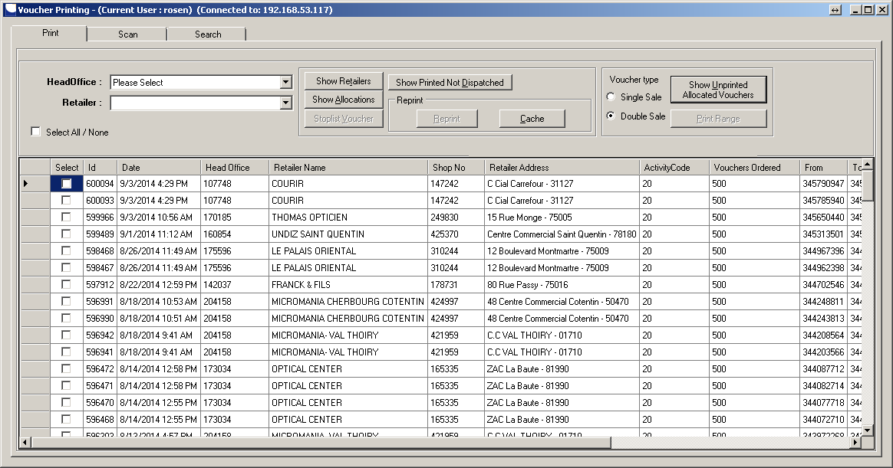

## 

Select allocations and click on “Print” button.

## SELECT ALLOCATIONS TO REPRINT

Click checkboxes to select all allocations to print

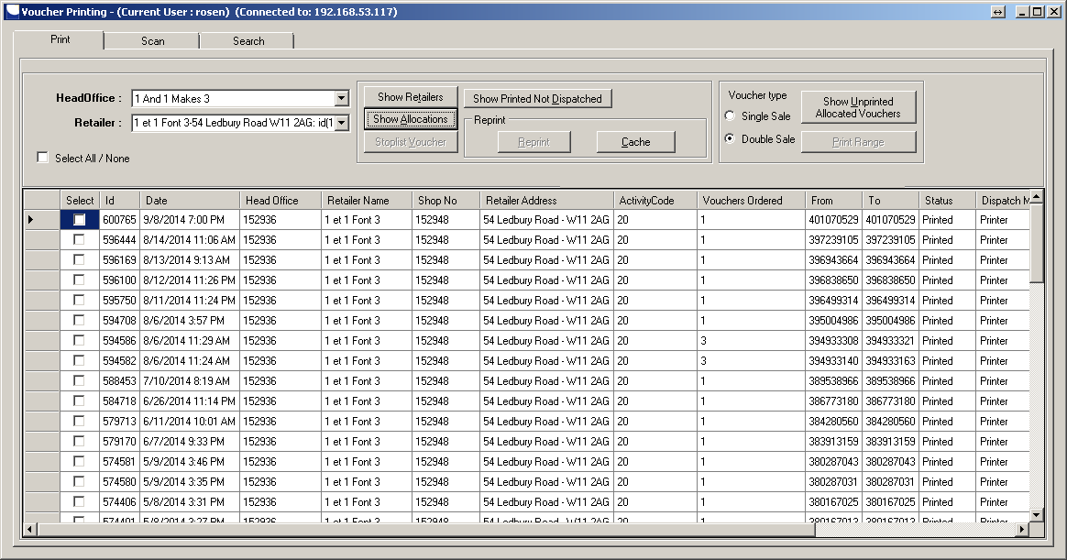

## REPRINT ALLOCATIONS

Click the button Reprint and select range. In form shown select “All” to reprint all allocation or provide range to print range.

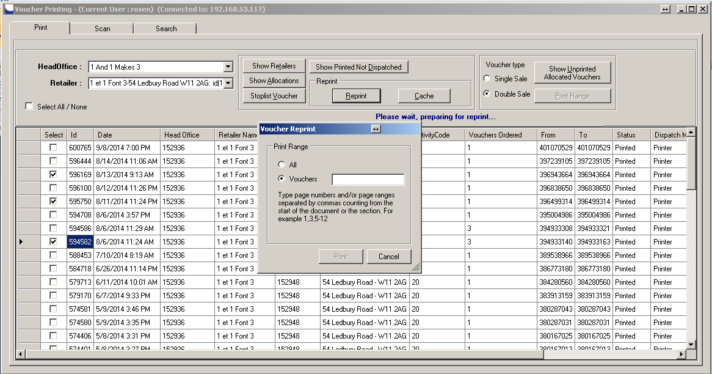

### CONFIRM REPRINT

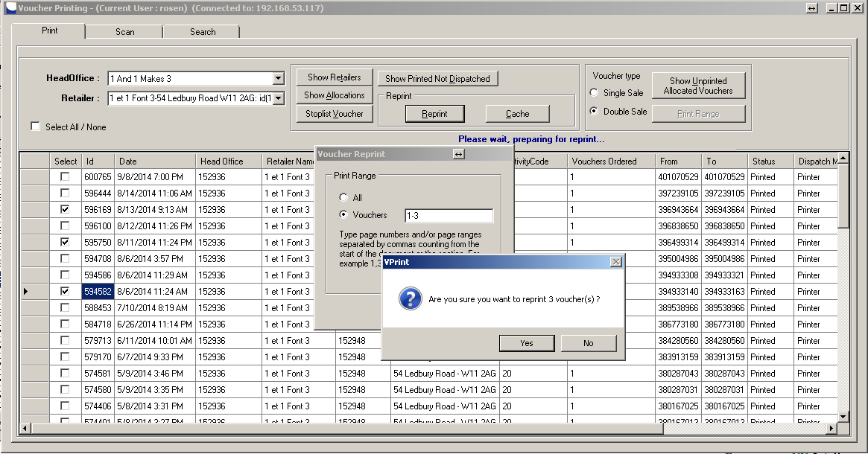

Printed vouchers go into printer queue.

## REPRINT FROM LOCAL CACHE

To reprint vouchers from local system cache click “Reprint from Cache” and load cache file.

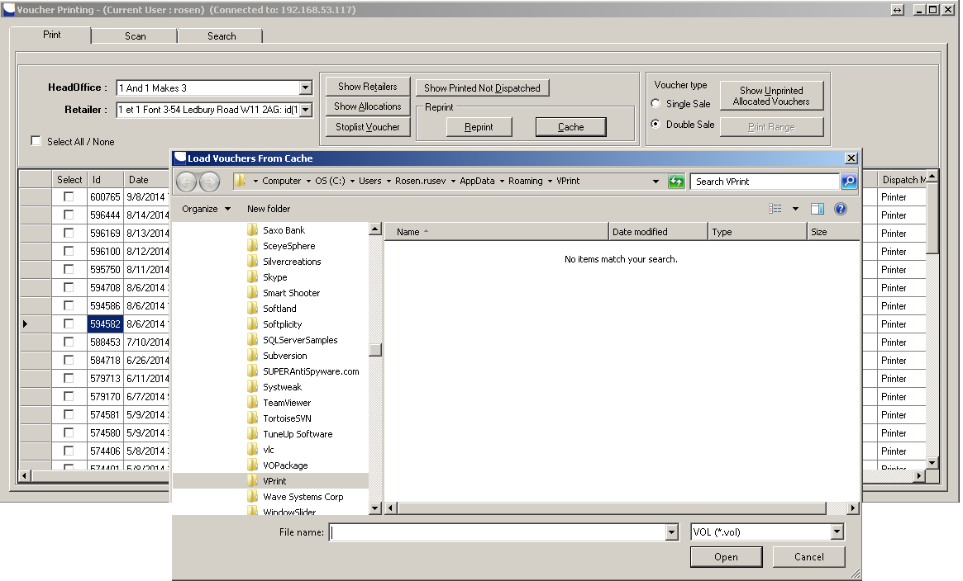

## BLOCKING VOUCHERS

Select allocation you what to block and click “Stoplist Voucher Allocation”

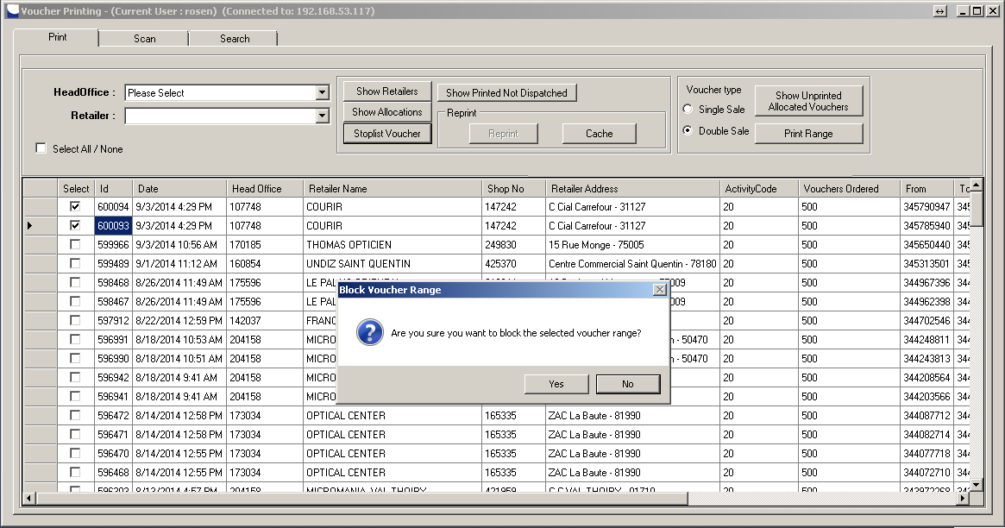

Click Ok to confirm.

# Thank you!